احمد فاروق عبد الحميد هيكل

1190001

ahmedheikal173@gmail.com

Research Project # 2 - Students Management System

Introduction:

Most of the universities around the world use the Credit hours system in calculating the grades and the years required for the student to complete his graduation or his university study as each student is required to complete his program by taking all the courses for this program as each course is defined by an ID and its credit hours, and by the end of each semester the student can calculate his GPA for this semester individually in addition to the Total Cumulative GPA for all the semesters.

In this report we will present a program that facilitates the calculation of the New Cumulative GPA, Grade of each course for each student and Number of students registered in each course. The operation of this program is based on entering three tables from the user and the user has the ability to enter the required data manually or from an excel file that he owns before.

Explanation of the program:

The program will give the user 10 Choices to choose through them and once the user uses the program a menu will be introduced to him showing the 10 Choices which he can choose from them.

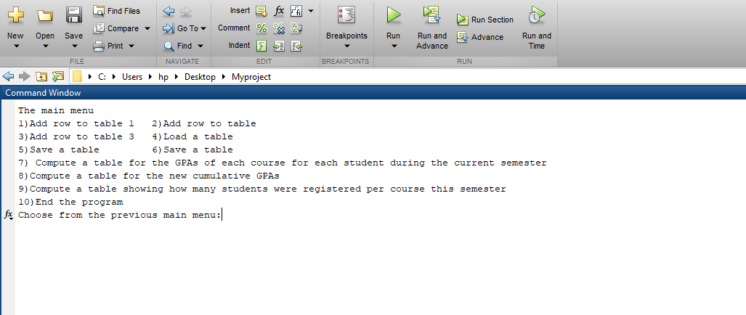

And the user will be prohibited to choose from 1 to 10 as each Choice has its own function and if the user entered another number out of the range, he will get this message 'You entered an invalid number'

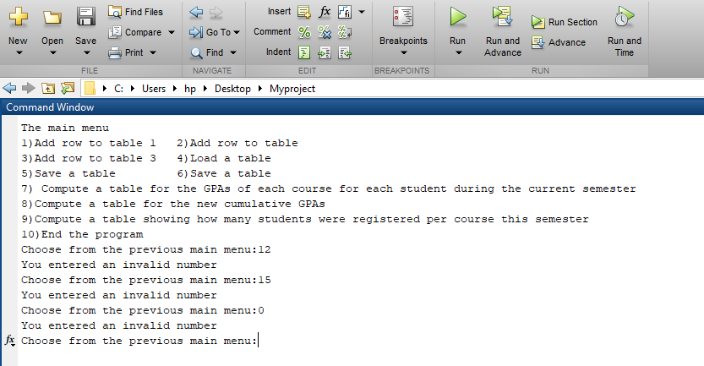

1) If the user would like to enter the first table manually, he could enter it but row by row as if he Chooses number 1, he will be prohibited to enter a row to the first table 'Add a row to Table1:' But the entered row should contain only three elements as Table 1 contains three columns (all numbers): Course ID, number of credit hours, and max grade and if the user entered a row with any other number of elements except 3 he would get this message 'Add a row to table 1 with only 3 elements'

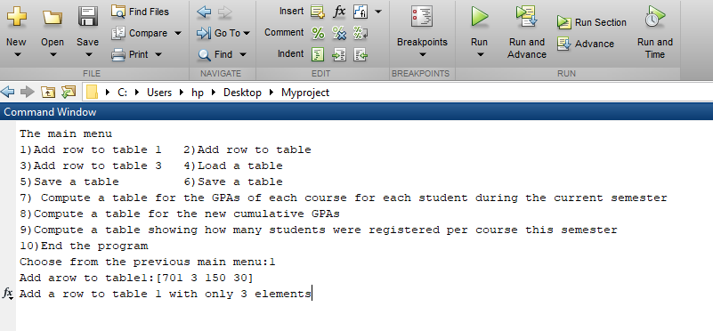

2) If the user would like to enter the second table manually, he could enter it but row by row as if he Chooses number 2, he will be prohibited to enter a row to the second table 'Add a row to Table2:' But the entered row should contain only three elements as  Table 2 contains three columns (all numbers): Student ID, old cumulative GPA (decimal), and number of completed credit hours. And if the user entered a row with any other number of elements except 3, he would get this message 'Add a row to table 2 with only 3 elements'.

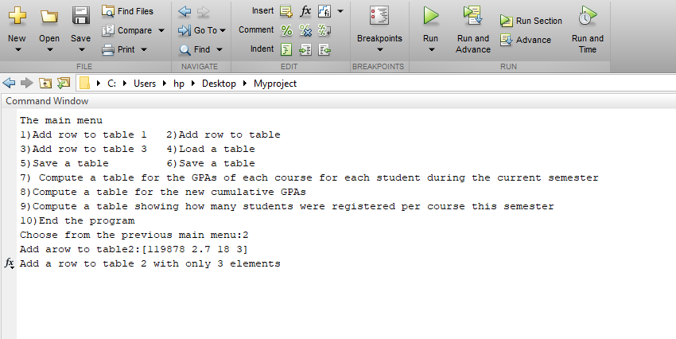

3) If the user would like to enter the third table manually, he could enter it but row by row as if he Chooses number 3, he will be prohibited to enter a row to the third table 'Add a row to Table3:' But the entered row should contain only four elements as   Table 3 contains four columns (all numbers): Student ID, Course ID, coursework grade, and final exam grade. And if the user entered a row with any other number of elements except 4, he will get this message

'Add a row to table 3 with only 4 elements'.

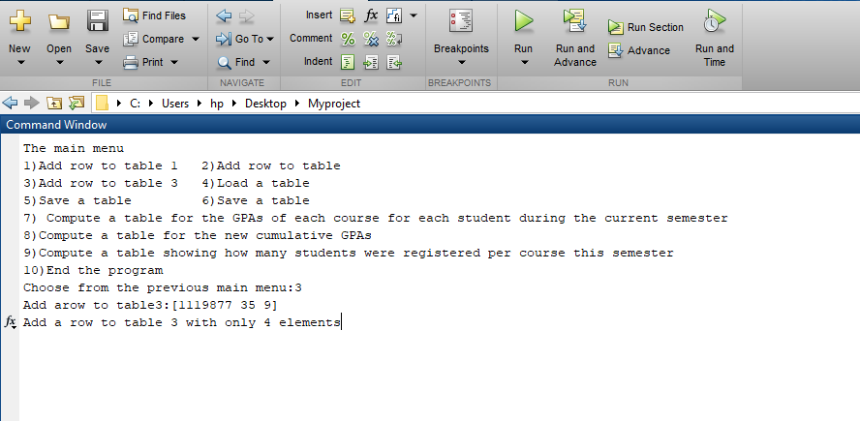

4) If the user has the data in the form of excel files, he could Choose Number 4 which will give him the ability to load tables from excel and once the user Choose 4 a submenu will be introduced to him asking him which table he will enter '1)Table1 2)Table2 3)Table3' After Choosing the table the user should enter the name of the excel file containing the table.

**BUT NOTE**

If the user loaded a table (Table 1 for example) Then he added a row (By Choosing 1 from the main menu) to this table a new table will be formed and stored in the variable (Table1 for example) containing this row in addition to the loaded table and vice versa.

5) After forming the table manually or loaded from the excel the user could save this table (Table1 for example) in an excel file Called by the number of the table. As if the user chooses 5 from the main menu, he will be prohibited to enter the number of the table required to be saved.

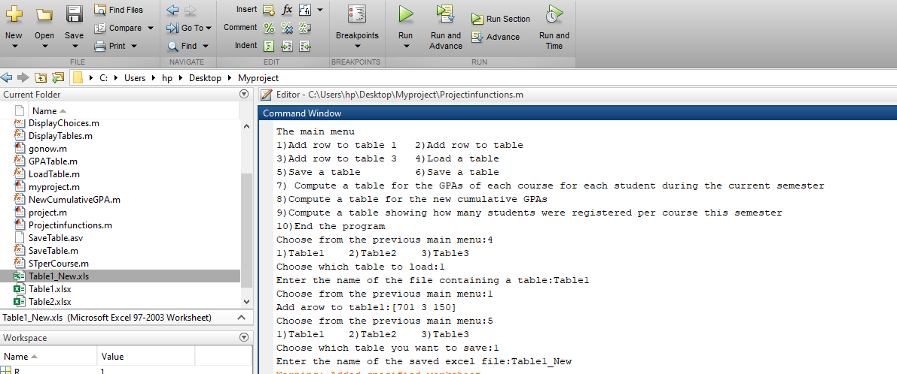

6) After forming the table manually or loaded from excel file or by both the ways If the user Chooses number 6 from the main menu, he could display the table he wants (Table1 for example) as he will be prohibited to enter the number of the table from a submenu.

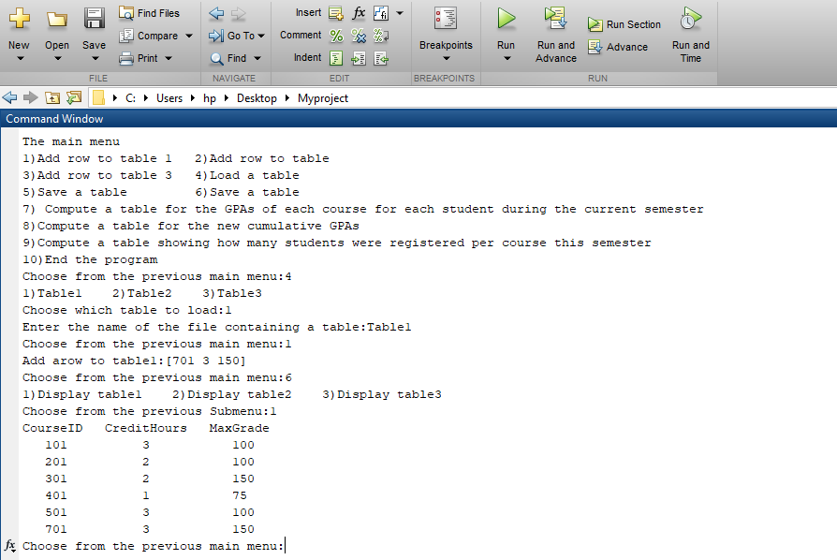

7) After entering all the third table manually or from excel then Choosing 7 from the main menu a simple modification occurs to Table 3 as the third and fourth columns will be added row by row and this summation will be positioned in the third column then the numbers in the third will be took as a factor from 100 according to the maximum grades of each course which could be found in the Third column in Table1.

Then these numbers will be replaced by grades according to the Evaluating of the credit hour system used in the university. Then the user will be prohibited to Choose whether to display the table in the command window or in excel file and this from a sub menu '1) Excel 2) Command window'.

**But Note:**

Once the user chooses to display the table on the excel file, the grades will be replaced by simple numbers from 1 to 12

These numbers replace the grades (1---A+, 2---A, 3---A-, 4---B+, etc.).

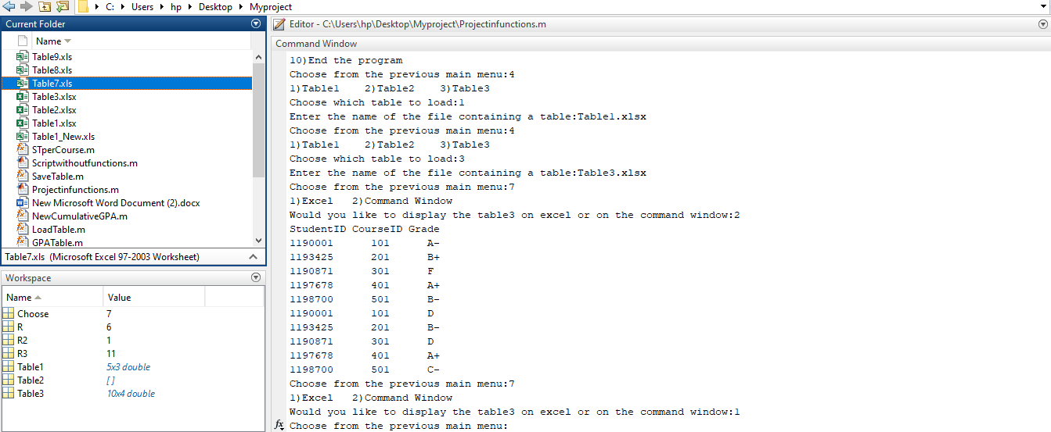

8) If the user chooses this number from the main menu after entering the three tables another new table is formed containing StudentID, Old GPA, Old Credit hours, New accumulative GPA. The user will have the ability to display the table on command window or on excel file.

**Method of calculating the new accumulative GPA:**

The main principle to calculate the New Accumulative GPA for a student is to divide his points by the total number of the credit hours he spent in the university.

1- Searching for all the courses in Table3 that have been taken by a student in Table2.

2-After knowing the student's courses in this semester we have to calculate his degrees in the third and fourth column in the Table3 then dividing these degrees by the max degree of each course which can be found in Table1 and take these degrees as a factor from 100.

3-After Calculating the degrees from 100 we have to get the grade of the student in each course according to the evaluating of Credit Hours system in each university.

4-After getting the grades of each course we could get the primary points equivalent to the grade of each course for this student according to the evaluating of Credit Hours system in each university.

5-After Calculating the primary points we have to calculate the real points by multiplying the primary points by the credit hours for each course and this could be found in Table 1.

6-Until now we have the total points for each course taken by the student in this semester. Then we will calculate the total points of this student in the last semesters by multiplying the old GPA by the total number of credit hours he spent in the previous semesters. By adding the two numbers we could get the total points for this student from the date of entering the university until now.

7-Last step to get the new Accumulative GPA is dividing the total points of each student by the total number of credit hours spent by the student in the university.

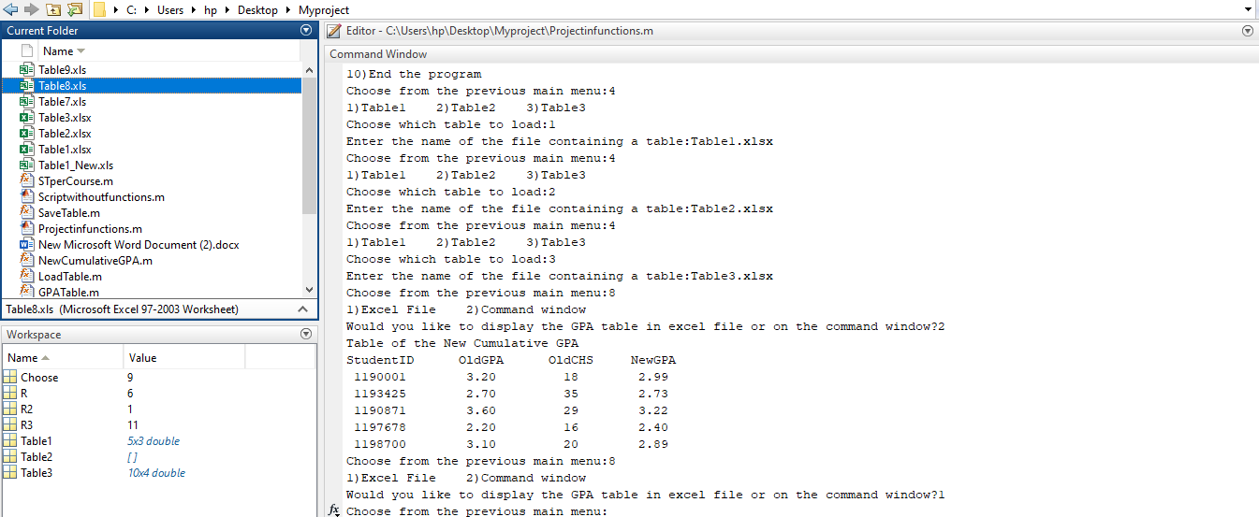

9) After entering Table1 and Table3 and Choosing 9 from the main menu a new table will be formed containing the CourseID and the number of students registered in each course. A sub menu will be introduced asking the user whether he wants to display the new table on the command window or on excel file.

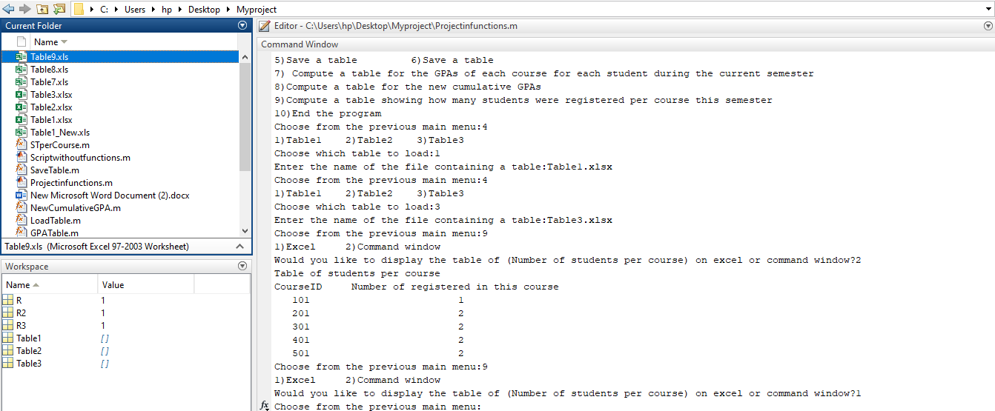

10) If the user Chooses number 10 from the main menu, he will exit the program

